Nepal College of Information Technology
Unit Test
Fall 2010
Program: B.E. IT Time: 2 hrs
Semester: Fall (III) FM: 60
Subject: Electronic Circuits PM: 30

Attempt all questions.

- a) Why Darlington pair is also called as “Super-Beta Transistors”? Obtain the gain calculation on n^{th} stage amplifier in dB. 7

b) For the Common-Emitter configuration [Assume β=100] shown below calculate: 8

i. r_{in (stage)}

ii. r_{out (stage)}

iii. A_{v}

iv. A_{vs}

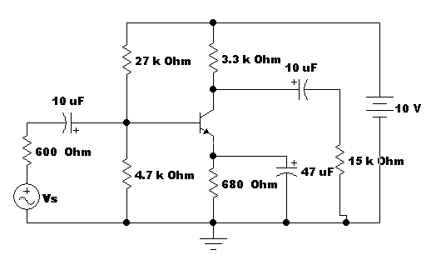
- a) What is Distortion? Explain the various types of distortion. 7
b) What is frequency response? The amplifier in the figure below has Mid-band gain (V_{L}/V_{S)} equal to 90, find: 8
i. The voltage gain V_{L}/V_{in}.
ii. The lower cut-off frequency.
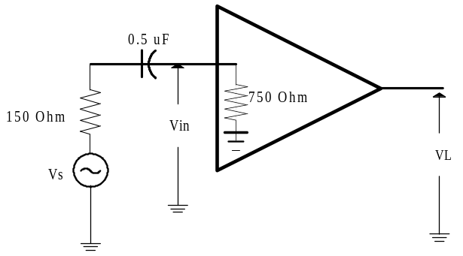
3. a) Why Common-collector configuration is also called as “Emitter Follower”? Obtain the small signal analysis of Common Base amplifier model. 8
b) Why do we need multistage amplifiers? Draw emitter follower circuit of Darlington pair and draw its Dc bias circuit and ac equivalent circuit. 7
4. a) Define Band width and half power frequency? Show that the power at Cut-off is equal to half of the power at Mid-band. 7
b) For the given cicuit calculate Overall voltage gain (Avs=V_{L}/V_{S)} 8
[Assume β=100, r_{e}=25 Ω, r_{c}=1000 kΩ]
